WH&S Management Plan

Purpose
The purpose of this plan is to:
- Reduce the risk of accidents or injury in the workplace.
- To ensure that everyone feels safe in the workplace.

This plan will assist <Programming Inc> in meeting its obligations in accordance with work health and safety legislation.
This plan applies to all <Programming Inc>’s employees and to other persons at risk from work carried out at <Programming Inc>’s workplaces. Failure to comply with the requirements of this Plan may lead to disciplinary action.

Work Health and Safety (WHS) Policy

The Statement of Commitment and the Implementation of Policy Commitment provide the overarching direction <Programming Inc> will follow in pursuit of workplace health and safety outcomes. These commitments are:

Statement of Commitment
<Programming Inc> is committed to providing a workplace that enables all work activities to be carried out safely. We will take all reasonably practicable measures to eliminate or minimize risks to health, safety and welfare of workers, contactors, visitors, and anyone else who may be affected by our operations.
We are committed to ensuring we comply with the Work Health and Safety Act 2011 (the Act). We will also comply with any other relevant legislation, applicable Codes of Practice and Australian Standards as far as possible.
Implementation of Policy Commitment
<Programming Inc> is committed to ensuring, so far as is reasonably practicable, the health and safety of its works while they are at work, and that the health and safety of other persons is not put at risk from our operations. This will be achieved by:
- providing a safe working environment
- making sure all equipment is properly maintained
- ensuring all personnel have received the correct amount of training

Duty of Care
A Person Conducting a Business or Undertaking (PCBU) has the primary duty of care to ensure:
- The work environment is safe and maintained
- Workers are healthy and safe
- An adequate amount of training and information has been provided
<Programming Inc> is a PCBU.

Responsibilities
Managers and Leaders
Managers and leaders are responsible for providing a workplace that is, as far as reasonably practicable, a safe and healthy workplace for workers and visitors, in particular in the areas of their control. This includes:
- modelling health and safety leadership
- demonstrating a commitment to good health and safety performance
- ensuring workers and visitors know how to keep themselves safe
- maintaining a safe working environment

Workers
Workers must take reasonable care for their own health and safety while they are at work, and take reasonable care that their acts or omissions do not adversely affect the health and safety of other persons.
On a day to day basis, this includes:
- ensuring their own personal health and safety, and that of others in the workplace
- complying with any reasonable directions (such as safe work procedures, wearing personal protective equipment) given by management that relates to health and safety
- Cooperate with policies and procedures relating to WHS in the workplace

It is acknowledged that, in accordance with the Act, a worker may cease, or refuse to carry out work if they have a reasonable concern the work would expose the worker to a serious risk to their health and safety.

Contractors
Contractors, sub-contractors and self-employed persons are defined as “workers” under the WHS Act if they carry out work in any capacity for <Programming Inc>. They are required to:
- Comply with any reasonable directions given by management
- Ensure their own personal health and safety

Health and Safety Experts

The following is a list of nominated workplace health and safety experts, who may be called on to assist with any aspect of this workplace health and safety management plan.
- John Doe
- Jane Doe

WHS Risk Assessment:
The purpose of any WHS risk assessment is to ensure that, for any identified hazards, appropriate control measures are implemented in order to protect workers, contractors and visitors from risks to their health, safety and welfare.
Control measures for WHS hazards should be implemented as required using the following hierarchy of control, in order of preference these measures relate to:
- elimination (removal of the hazard)
- substitution (substitute the hazard for something which is less hazardous e.g. replace a hazardous chemical with one within is not hazardous)
- isolation (isolate the hazard from people e.g. place a noisy piece of equipment in another location)
- engineering (e.g. guarding on machinery)
- administrative (e.g. provision of training, policies and procedures, signage)
- personal protective equipment (e.g. use of hearing , eye protection, high visibility vests).
Outcomes of risk assessments will be documented and the control measures reviewed at least annually or earlier should a task or activity be the subject of a WHS incident or a change of process or requirement. Current risk assessments will ensure that <Programming Inc> achieves the goal of eliminating or minimising the risk workers may be exposed to.
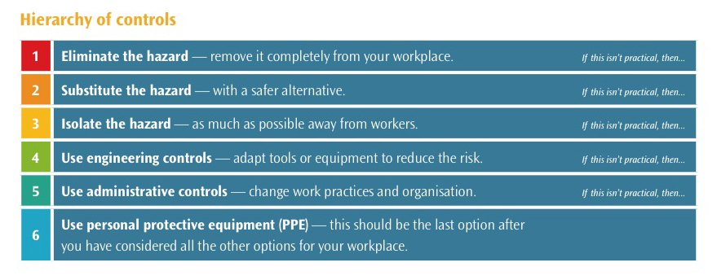

Hazard and Risk Assessment:

IMPACT | LIKELIHOOD
 | Rare (1) | Unlikely (2) | Possible (3) | Likely (4) | Almost Certain (5)
Catastrophic (A) | M | M | H | C | C
Major (B) | L | M | M | H | C
Moderate (C) | L | M | M | M | H
Minor (D) | L | L | M | M | M
Insignificant € | VL | VL | L | L | M

Risk level | Required action
Critical | Act immediately:  The proposed task or process activity must not proceed. Steps must be taken to lower the risk level to as low as reasonably practicable using the hierarchy of risk controls.
High | Act today:  The proposed activity can only proceed, provided that:  (i) the risk level has been reduced to as low as reasonably practicable using the hierarchy of risk controls;  (ii) the risk controls must include those identified in legislation, Standards, Codes of Practice etc.  (iii) the risk assessment has been reviewed and approved by the Supervisor and  (iv) The supervisor must review and document the effectiveness of the implemented risk controls.
Medium | Act this week:  The proposed task or process can proceed, provided that:  (i) the risk level has been reduced to as low as reasonably practicable using the hierarchy of risk controls;  (ii) the risk assessment has been reviewed and approved by the Supervisor.
Low | Act this month:  Managed by local documented routine procedures which must include application of the hierarchy of controls.
Very Low | Keep a watching brief:  Although the risk level is low the situation should be monitored periodically to determine if the situation changes.

Hazard | Consequence | Likelihood | Risk Level
Glass shards on floor from broken light | Someone could potentially cut open their feet and go to hospital | Rare | High
Hot Coffee spilled on the ground | Someone could slip and be Injured | Possible | Low
Damaged power cords dangling from roof | Someone could walk into it and get electrocuted or trapped in them | Rare | High
Inhaling Asbestos | Potential for lung cancer and Mesothelioma | Possible | High

Workplace location: | Programming Inc Headquarters
Name of person conducting assessment: | John Doe
Date: | 19/02/2026

S | Spot the hazard |  | A | Assess the risk | F | Fix the problem |  |  | E | Evaluate results
Identify the work task or activity |  | What are the hazards associated with each activity or the steps in each activity | Is the risk associated with the hazard low, moderate, significant or high? |  | If the risk is deemed unacceptable for the task, what will be done to reduce or remove the risk? |  | By whom? | By when? | Go through the first 3 steps again to ensure risk levels are now at an acceptable level
 |  |  |  |  |  |  |  |  | Revised risk level
Programming |  | Eye strain from looking at a screen for too long
Making Coffee
Testing Software |  | Getting distracted because it’s too entertaining | Low

Training Plan for Workers:
<Programming Inc> is committed to providing appropriate training to ensure workers have the skills and knowledge necessary to fulfil their WHS obligations. WHS training is a fundamental requirement for <Programming Inc> to achieve a safe workplace.
The following induction checklist should be used in conjunction with the general induction training program for workers to ensure that all new workers are aware of the WHS systems, policies and procedures in place within <Programming Inc>.

Workplace:
Date: | Completed by:

Control measures | What training is required? | Who is to be trained? | How? | Date completed

